# *CS-255 Client Presentation Document*

*Ryan Hatch  
October 15, 2023*

***Slide One: DriverPass System Analysis*** *Speaker Notes: My name is Ryan, and today I'll be presenting the system design for our DriverPass system.   
We’ll be going over all of the requirements, diagrams, and other essential components of our design.*

***Slide Two: System Requirements (Functional)***

1. ***User Registration and Authentication:***
   * *Users should be able to register, log in, and reset their passwords.*
   * *Explanation: This ensures that only authorized users can access the system, make reservations, and access online classes. It meets DriverPass's need to provide a personalized experience for each user.*
2. ***Reservation Management:***
   * *Users should be able to make, modify, and cancel driving lesson reservations.*
   * *Admins should be able to track user activity related to reservations.*
   * *Explanation: This functionality is core to DriverPass's business model, allowing customers to book lessons and ensuring efficient scheduling and tracking.*

*Speaker Notes: These requirements are the backbone of our design, ensuring that the system is both efficient and user-friendly.*

* ***User Registration and Authentication:*** *This is the gateway to our system. We've made sure that users can easily sign up and log in. This ensures that only authorized individuals have access, providing a personalized experience for each user.*
* ***Reservation and Management:*** *Given that DriverPass is all about driving lessons and packages, we've designed a seamless process for users to make, modify, or cancel reservations. This feature is intuitive, ensuring that users can manage their lessons with ease.*

***Slide Three: System Requirements (Functional)***

1. ***Accessibility:***
   * *The system should be accessible online from any computer or mobile device.*
   * *Explanation: This meets DriverPass's need to provide a flexible and convenient platform for users and staff, regardless of their location.*
2. ***Security:***
   * *Data encryption, secure user authentication, and regular security audits should be in place.*
   * *Explanation: Given the sensitive nature of user data, especially payment details, security is paramount. This ensures trust and reliability for DriverPass's customers.*
3. ***Scalability:***
   * *The system should be built on scalable infrastructure to handle growth in the number of users.*
   * *Explanation: As DriverPass expands its customer base, the system should be able to handle increased traffic without performance issues.*

*Speaker Notes: Moving on to our nonfunctional requirements, which are the qualities or standards the system should adhere to:*

* ***Accessibility:*** *We believe in inclusivity. Our system is designed to be accessible to everyone, including those with disabilities. This ensures that DriverPass reaches a wider audience and provides an equal experience for all.*
* ***Security:*** *In today's digital age, security is paramount. We've incorporated advanced security measures to protect user data and ensure safe transactions. This builds trust and confidence among our users.*
* ***Scalability:*** *As DriverPass grows, we want our system to grow with it. Scalability ensures that as the number of users increases, our system can handle the load without compromising on performance.*

***Slide Four: Use Case Diagram*** 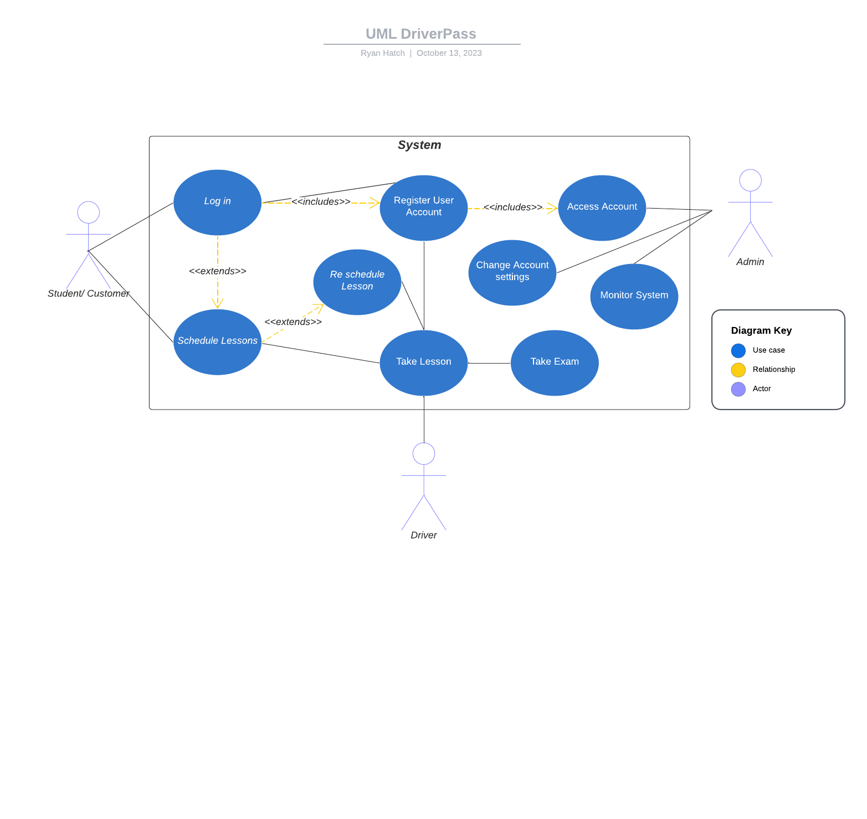

*Speaker Notes: In this diagram which represents the different interactions within our system, youll see various roles like the customer, admin, and the driver. Each of these roles represent a group of people or individuals who will be using our system.*

* *Starting with our* ***customers****, they can do a variety of tasks online such as accessing data, making or changing reservations, signing up for driving packages, and even scheduling their driving lessons. If they forget their password, they can easily request a reset.*
* *Liam, our* ***admins****, have a broader set of responsibilities. They can access data both online and offline, keep track of user activities related to reservations, and even receive important updates from the DMV.*
* *Lastly, our* ***drivers****, the backbone of our service, will ensure the lessons and exam are conducted appropriately. The drivers also can update the details of their driving sessions, ensuring that all information is up-to-date and accurate.*

*This diagram was crafted keeping in mind the diverse needs of the DriverPass system. We wanted to ensure that every individual, from the customer to the admin, has a clear and efficient way to interact with our system, making their tasks smoother and more intuitive*

***Slide Five: Activity Diagram***

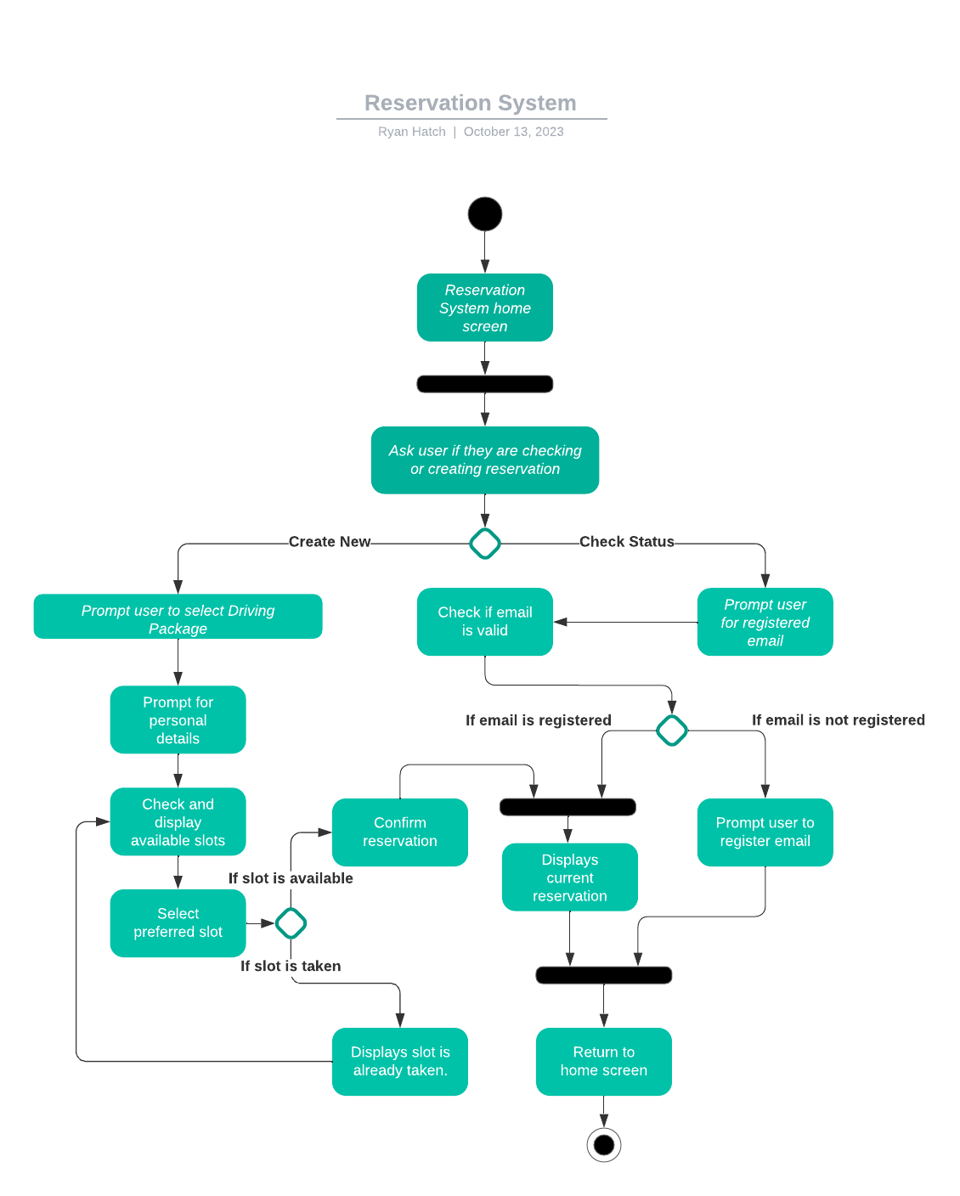

*Speaker Notes: This diagram visually represents the steps a user would take when interacting with our reservation system.*

* *The journey begins at the home screen of the reservation system.*
* *From here, the system will ask if you're looking to create a new reservation or check the status of an existing one.*
* *If you're creating a new reservation, you'll be prompted to select a driving package. Once selected, you'll be asked to provide your email. This is where we've added a layer of convenience. If your email is already registered with us, the system will recognize you and directly show available slots for your chosen package. If your email isn't registered, the system will guide you to register your email and then proceed.*
* *Once you see the available slots, you can select your preferred time. If the slot you've chosen is available, your reservation is then confirmed. But, if by chance the slot is already taken, the system will inform you and guide you back to start the reservation process again.*
* *If you're checking the status of an existing reservation, you'll be prompted to enter your registered email. Once entered, the system will display your current reservation details.*

*Throughout this design, we've prioritized user-friendliness and efficiency. We've ensured that the process is intuitive, minimizing the number of steps and providing clear guidance at each stage. This design is a reflection of DriverPass's commitment to offering a seamless experience to its users.*

***Slide Six: Security***

* + ***User Authentication:*** *Implementing secure authentication mechanisms like OAuth or JWT to ensure only authorized users can access the system.*
  + ***Data Encryption:*** *Encrypting sensitive data, especially payment details and personal information, both at rest and in transit.*
  + ***Firewall and Intrusion Detection Systems (IDS):*** *To prevent unauthorized access and detect potential security threats.*
  + ***Regular Security Audits:*** *Periodic security assessments to identify and rectify vulnerabilities.*

*Speaker Notes: One of the top priorities for DriverPass is ensuring the safety and security of our users' information.*

* *Firstly, we've put in place a strong sign-in process. Think of this as the front door to a house. Just as you'd want a sturdy lock on your front door to keep out intruders, our sign-in process ensures that only the rightful user can access their account.*
* *Next, we've taken steps to protect sensitive information. Imagine you have valuable items in your home. You wouldn't just leave them out in the open; you'd lock them in a safe. Similarly, we ensure that personal details, especially payment information, are stored securely and are protected when they're being sent across the internet.*
* *We've also set up a digital security system. Just as security cameras and alarms can detect and deter intruders in a home, our system is designed to constantly be on the lookout for any suspicious activity. If anything unusual is detected, the system raises an alert.*
* *Lastly, we believe in regular check-ups. Think of this as a routine inspection of your home's security systems to ensure everything is working as it should. We periodically review our security measures to find and fix any potential weak spots.*

*In essence, every decision in designing the DriverPass system has been with the safety and security of our users in mind. We've taken a comprehensive approach to ensure that our users can trust us with their information.*

***Slide Seven: System Limitations***

* *The systems development will be influenced by resource availability, budget constraints, and a project timeline.*
* *Future features added to the system may require additional development to align with evolving business needs.*

*Speaker Notes: Every system, no matter how well-designed, has certain limitations. It's important for us to be transparent about these so we can set the right expectations.*

* *Firstly, just like building a house has constraints like budget, materials, and time, the system's development is influenced by available resources, budget, and the project timeline. We can aim to deliver the best within these parameters, but there might be features or enhancements that we'll need to prioritize based on these constraints.*
* *Imagine for example, after buying a new house, eventually you decide you want to add a swimming pool. Adding that pool would require some changes and adjustments to the existing structure. Similarly, as DriverPass grows and evolves, new features or changes might require some additional work to fit seamlessly into the existing system.*

*In essence, while our design aims to be comprehensive and forward-thinking, there are natural limitations. None the less, with feedback and collaboration, we can continue to refine and enhance the system to best serve DriverPass and its users.*